**DDL EXECUTIONS**

**SQL> create table stocks(**

**2 stock_symbol varchar2(10) primary key,**

**3 stock_name varchar2(20) not null,**

**4 market_capitalization decimal(10,2) not null,**

**5 price_earnings_ratio decimal(10,2) not null);**

**SQL> desc stocks**

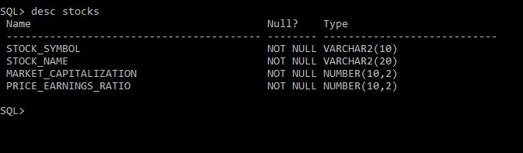

**SQL> create table user_account(**

**2 username varchar2(20) primary key,**

**3 password varchar2(20) not null,**

**4 phone_number number(20) not null);**

**SQL> desc user_account**

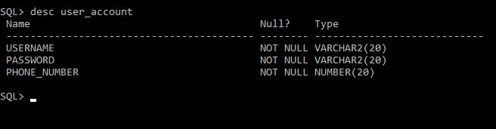

**SQL> create table watchlist(**

**2 stock_symbol varchar2(10) not null,**

**3 user_id varchar2(20) not null);**

**SQL> alter table watchlist**

**2 add constraint fk3_stock_symbol foreign key(stock_symbol) references stocks;**

**SQL> desc watchlist**

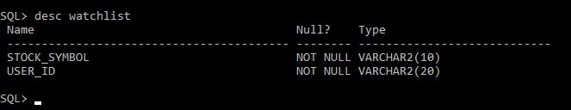

**SQL> create table historical_data(**

**2 stock_symbol varchar2(10) not null,**

**3 day date not null,**

**4 opening_price decimal(10,2) not null,**

**5 closing_price decimal(10,2) not null);**

**SQL> alter table historical_data**

**2 add constraint fk2_stock_symbol foreign key(stock_symbol) references stocks;**

**SQL> desc historical_data**

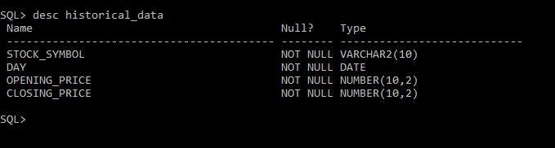

**SQL> create table Prediction(**

**2 stoct_symbol varchar2(10) not null,**

**3 day date not null,**

**4 predicted_price decimal(10,2) not null);**

**SQL> alter table prediction**

**2 add constraint stock_symbol foreign key(stock_symbol) references stocks;**

**SQL> desc prediction**

